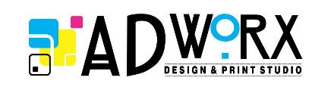
The Creative Brief

A complete, descriptive and accurate project brief will assist us in determining exactly what your requirements for the design project are.
Company & Contact Details:
Company: | Click here to enter text.
Contact Number: | Click here to enter text.
E-mail: | Click here to enter text.

The Project Summary: Clear, concise description of project – keep brief.
Click here to enter text.

Target Audience: Who are you trying to attract? Be specific.
Click here to enter text.

What is your key messages: One or two key “thrusts” – those most important to the project’s success?
Click here to enter text.

Key Benefits: What’s in it for the readers?
Click here to enter text.

Background/Competitive Positioning: Briefly discuss the competition, market realities, obstacles, etc.
Click here to enter text.

Communication Strategy: Indicate types of media and any specific elements to be included (logos, key contact information, etc.)
Click here to enter text.

Desired Message Tone: How do you want the message perceived -- creative, innovative, and fun?
Click here to enter text.

Project Timeline: Indicate major milestones.
Click here to enter text.

Anticipated Budget:
Click here to enter text.

Other: Add any key information not covered under the above items.
Click here to enter text.

Contact person: | Click here to enter text.
Position in Company: | Click here to enter text.
Date: | Click here to enter a date.

